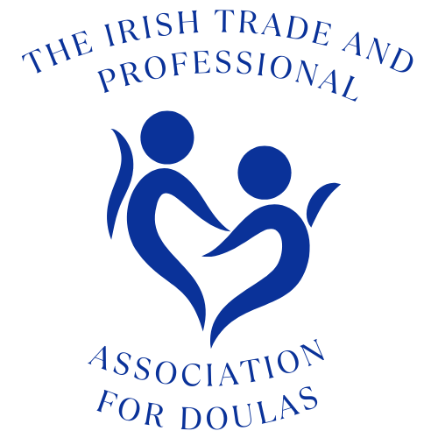

Irish Trade and Professional Association Code of Conduct
A Doula who is a member of Irish Trade and Professional Association:
- Offers practical and emotional support, as well as evidence based information resources, but not advice, to women and birthing people and/or parents, empowering them in their own choices. Irish Trade and Professional Association members recognise that women and birthing peoples’ choices are valid and that the birthing person assumes responsibility for the birth, parenting style or feeding method that they feel is right for them and their baby.
- Is accountable for themselves and must work within the law.
- Must work within the framework of Irish Trade and Professional Association Guidelines and Policies, especially, but not limited to;
  - Equality diversity and belonging
  - Anti-racism
  - Confidentiality
  - Complementary therapies
  - Social media
  - Infant feeding
  - As well as the Irish Trade and Professional Association Ethos
- Works to maintain the highest level of care and support possible, all the time striving to be sensitive, nurturing, compassionate, empathic, non-judgmental, evidence-based, flexible, reliable, well-organised, practical and protective of the birthing person and their family’s environment.
- Does not perform clinical, midwifery or medical tasks, diagnose medical conditions or give medical advice, whilst working as a doula, even if trained as a health professional.
- Will signpost clients to other appropriate resources/professionals should the client have needs beyond the scope of their doula role. Each doula is free to offer other services or therapies, however, it must be made clear that these are separate roles and information on how these are regulated and insured should be supplied if appropriate. For example: an infant feeding Counsellor working with a charitable infant feeding support and training organisation. All infant feeding support provided by that organisation is free at the point of contact. Therefore, if the doula is working for the client as a doula, they are unable to act as their infant feeding counsellor as part of their contracted hours. Whilst they will be able and willing to use their knowledge and skills to support the client’s feeding journey, if the client requires an infant feeding Counsellor, the doula will have to refer them to local support.
- Will accurately represent their doula education and experience and will not mislead other doulas, clients, or other birth professionals at any time.
- Will be honest and show integrity and respect at all times towards their clients, doula colleagues and other professionals.
- Will not discuss personal and confidential information which has been disclosed to them by their clients in the course of their doula work, without the express permission of those clients, except in situations as outlined in Irish Trade and Professional Association’s Confidentiality policy.
- Is recommended to keep records of all antenatal, birth and/or postnatal support roles with clients.
- Is recommended to have a contract/letter of agreement with their clients.
- Is required to obtain relevant insurance such as Public Liability and Professional Indemnity.
- Is recommended to be tax compliant
- Will strive to develop and maintain positive work relationships within the doula and birthing community and will observe Irish Trade and Professional Association’s Social Media policy.
- Is responsible for maintaining and enhancing their skills and education, including attending courses, workshops and lectures made available by Irish Trade and Professional Association and other relevant organisations on a regular basis.
- Will strive to attend Irish Trade and Professional Association national and regional meetings and contribute whenever possible to the running of the organisation as schedules and other commitments allow.
- Agrees that use of the Irish Trade and Professional Association logo is limited to active, subscribed members of Irish Trade and Professional Association. At the point they leave, or are asked to leave Irish Trade and Professional Association as part of a disciplinary process, they must remove all mention of being a member of Irish Trade and Professional Association and cease using the logo within 7 days.
- Will complete an annual return about their work and CPD training each year.
- Will cast vote for all motions at Annual General Meeting (option to abstain from vote at each motion is provided, however each Doula must proivde vote), in person or by proxy.
- Is aware that whilst Irish Trade and Professional Association is able to give emotional support to members, it is unable to provide legal protection. A Irish Trade and Professional Association doula recognises that feedback, both positive and negative is important for personal and vocational growth, and, as such, agrees to cooperate and engage with the resolution team promptly and effectively if any breach of above policies is reported.

