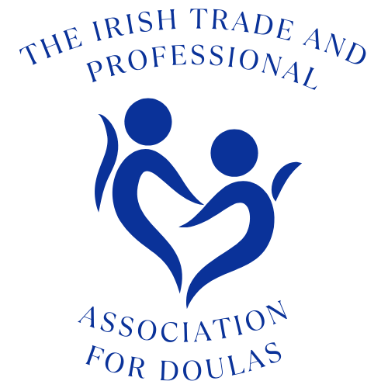

The Irish Trade and Professional Association for Doulas CLG Member Policy on the Implementation of
The International Code of Marketing of Breastmilk Substitutes
World Health Organisation Code (WHO Code)
The ITPAD and its members support all families and children regardless of feeding choices.

Since its inception, the ITPAD has supported the WHO International Code on the Marketing of Breastmilk Substitutes which was adopted by the World Health Assembly, the governing body of the World Health Organisation (WHO), in 1981. The Code promotes safe and adequate nutrition for infants, by the protection and promotion of breastfeeding and by ensuring the proper use of breast-milk substitutes, when these are necessary. The ITPAD continues to be fully committed to playing our part in the upholding of the full Code.

The World Health Organisation Code (WHO Code)

Please note, the Code is not directed at parents, it is not a ban on the sale of formula and it does not advocate against parents choosing to formula feed. Adhering to the Code protects all parents and children by advocating the provision of unbiased, factual information to parents on infant feeding, including how to properly and safely prepare infant formula.

The Code is a set of recommendations to regulate the marketing of breastmilk substitutes, including infant formula, infant feeding bottles and teats. It also includes all teats and foods aimed at babies under 6 months and in recent years follow-on/growing up milks were added. The Code aims to stop the aggressive and inappropriate marketing of breastmilk substitutes.
Members

All members should read the HSE Factsheet for Healthcare Professionals:

https://www.hse.ie/file-library/the-who-Code-of-marketing-of-breast-milk-substitutes.pdf.

ITPAD and the Code
ITPAD supports all parents / guardians, regardless of their infant feeding choice. As an organisation that promotes Doulas and evidence-based information to parents, ITPAD supports national and international initiatives that promote and protect breastfeeding.

Products covered by the Code are infant formula, teats, infant feeding bottles and any teas or foods aimed at babies under 6 months (as the WHO recommends exclusive breastfeeding to 6 months, before solid foods are added).

ITPAD and Companies that breach the Code

ITPAD is committed to upholding the full Code and we will endeavour to do so by raising awareness of the Code through our work and by reporting any breaches of the Code that are brought to our attention.

However, in order to communicate effectively with parents and to continue the support of all families, we recognise that we cannot avoid using media / social media / online channels that permit advertising of formula and associated products on their platforms, e.g. various TV channels, radio stations, newspapers, magazines, tech companies such as Google, Microsoft and Facebook. We would ask that members communicate with any channel they are liaising with that we uphold the full Code and to this end we do not wish any article or piece relating to ITPAD to be placed next to advertising which does not comply with the Code.
Entities are in violation of the Code if they advertise or promote the use of products covered by the Code, offer discounts of the sale of these products, idealise formula feeding, or give free samples to parents.

Here are some examples of Code breaches:
- Discounts on feeding bottles.
- Advertising of infant formulas (e.g. television, print, radio). In Ireland, media outlets comply with not advertising infant formulas for babies under 6 months old.
- A free sample of an infant feeding bottle, teat or formula (e.g. in a goody bag handed out at a baby fair).
- A sign on a shelf in a supermarket promoting products that fall within the scope of the Code.
- Any kind of marketing material that idealises bottle feeding or appears to undermine breastfeeding.

It is a condition of our Membership Discount Scheme that businesses must be WHO Code compliant.

We cannot accept funding, donations or raffle prizes from businesses that violate the Code, e.g. supermarkets, some pharmacies, some baby shops (if they offer discounts on or promote items covered by the Code). For smaller individual businesses you can ask them to confirm they uphold the Code.

Reporting Breaches externally

https://www.fsai.ie/makeacomplaint/

Links

Baby Feeding Law Group Ireland - http://bflgireland.ie/ / https://www.facebook.com/Baby-Feeding-Law-Group-Ireland

World Health Organisation (WHO )Full Code - https://www.who.int/nutrition/publications/Code_english.pdf

WHO Frequently Asked Questions Document - https://www.who.int/nutrition/publications/infantfeeding/breastmilk-substitutes-FAQ2017/en/

