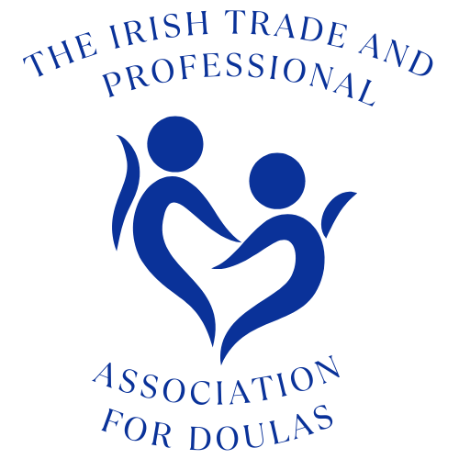
Membership Discount Policy

1. INTRO

Since launching the scheme has been hugely popular with many businesses engaging with ITPAD to be included. This document will detail those businesses types who may or may not be included and the rules surrounding the scheme.
2. PURPOSE OF THE SCHEME
The aim of the initiative is both to increase ITPAD Membership numbers and to provide a benefit to existing members, as well as member families.
The benefit to the business offering the Discount is that they are advertised on our Social Media platforms and are listed on our website as such, thereby driving more business their way.
3. THE RULES!
1. Endorsement
Offering membership discounts does not imply any endorsement or recommendation of the business by ITPAD.
2. Compliance to the WHO Code
All businesses MUST comply to the WHO Code - http://www.who.int/nutrition/publications/code_english.pdf
3. Agreements with Individual Regions
Although it is preferable that discounts would be offered nationwide, we recognise that sometimes there may be small, local businesses that wish to offer a discount to the local region only. These are permitted at the discretion of the Executive Committee.
4. Complaints / negative feedback
Should ITPAD receive any complaints or negative feedback about the businesses on the scheme, ITPAD will feed this back to the business, repeated occurrences may mean that it is in ITPAD’s best interest to remove the business from the scheme.

Similarly, should ITPAD receive any negative feedback in relation to the discount offered, we reserve the right to ask the business to reconsider or to remove them from the discount list.
5. Business types not permitted on the scheme
As ITPAD members offer services such as antenatal classes, birth debrief, breastfeeding support classes and parent to parent support services, to avoid conflicts of interest and to protect ITPAD’s best interests, businesses offering a similar service may not take part in the scheme. This means that as a rule the following Business types may not join the scheme:
● Antenatal classes (including gentlebirth, hypnobirth & antenatal yoga)
● Some therapy support / counselling services
● Charities
The ITPAD Executive Committee reserve the right to assess a business and if necessary refuse entry to the scheme. Internally we will endeavour to assess within one week and feedback to the business within two weeks.
6. Advertising
Adverts are created by the ITPAD Executive Committee and are published on ITPAD social media when the business discount is activated and thereafter on an ad-hoc basis as deemed necessary by the executive committee to advertise and promote the scheme.
Businesses may not advertise themselves on our Social Media platforms, however they are very welcome to mention on their own Social Media platforms that they are involved in our Discount scheme.

