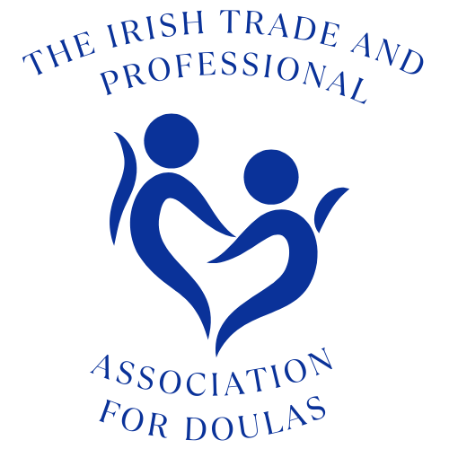

SOCIAL MEDIA GUIDELINES
Policy statement
The Irish Trade and Professional Association for Doulas recognises that the internet provides unique opportunities to participate in interactive discussions and share information on particular topics using a wide variety of social media, such as Facebook, Instagram, Snapchat, LinkedIn, Twitter, blogs, videos and Wikis. However, members' use of social media can pose risks to our confidential and proprietary information, and reputation, and can jeopardise our compliance with legal obligations.
Who is covered by the policy?
This policy covers all members working at all levels, including the Executive Committee and general members (collectively referred to as members in this policy).
Third parties who have access to our electronic communication systems and equipment are also required to comply with this policy.

Scope and purpose of the policy
This policy deals with the use of all forms of social media, including Facebook, Instagram, Snapchat, LinkedIn, Twitter, Wikipedia, all other social networking sites, and all other internet postings, including blogs and vlogs.
It applies to the use of social media for both business and personal purposes, whether during office hours or otherwise. The policy applies regardless of whether the social media is accessed using our IT facilities and equipment or equipment belonging to members.
Breach of this policy may result in disciplinary action up to and including revoking of social media rights (access to the Irish Trade and Professional Association for Doulas Facebook, twitter feed or Forum for an amount of time to be determined by either the complaints team, or the complaints team in conjunction with the social media manager or moderator), and/or being subject to a formal complaints procedure, going all the way through to revoking of membership.
Disciplinary action may be taken regardless of whether the breach is committed during working hours, and regardless of whether our equipment or facilities are used for the purpose of committing the breach.
Any member suspected of committing a breach of this policy will be required to co-operate with our investigation.
Members may be required to remove internet postings which are deemed to constitute a breach of this policy, and may be asked to make a public or private apology. Failure to comply with such a request may in itself result in disciplinary action.

Personnel responsible for implementing the policy
The Executive Committee have a specific responsibility for operating within the boundaries of this policy, ensuring that all members understand the standards of behaviour expected of them and taking action when behaviour falls below its requirements.
All members are responsible for the success of this policy and should ensure that they take the time to read and understand it. Any suspected misuse of social media can be informally and anonymously reported to the social media manager or moderator who will refer to the Complaints Team if necessary. If the breach is felt to be severe, then a formal complaint (also able to be made anonymously) can be submitted to the complaints team via info@doulas.ie
Compliance with related policies and agreements
Social media should never be used in a way that breaches any of our other policies. If an internet post would breach any of our policies in another forum (including face-to-face discussion), it will also breach them in an online forum. For example, members are prohibited from using social media to:
- breach any obligations they may have relating to confidentiality;
- breach our Disciplinary Rules as detailed in the Complaints Procedure document
- use a threatening or intimidating ‘tone of voice’
- defame or disparage the organisation or its members, affiliates or clients;
- harass, incite to harass, use repetition to bully, intimidate, or bully or intimidate other members in any way;
- unlawfully discriminate against other members or third parties;
- breach our Data Protection policy (for example, never disclose personal information about a member online);
- breach any other laws or ethical standards (for example, never use social media in a false or misleading way, such as by claiming to be someone other than yourself or by making misleading statements). Members should never provide references for other individuals on social or professional networking sites, as such references, positive and negative, can be attributed to the organisation and create legal liability for both the author of the reference and the organisation. Members who breach any of these points may face disciplinary action up to and including revoking of social media rights (access to the Irish Trade and Professional Association for Doulas Facebook, twitter feed or Forum for an amount of time to be determined by either the complaints team, or the complaints team in conjunction with the social media manager or moderator), and/or being subject to a formal complaints procedure, going all the way through to revoking of membership.
Business use of social media
If your duties require you to speak on behalf of the organisation in a social media environment, you must still seek approval for such communication from Irish Trade and Professional Association for Doulas by emailing info@doulas.ie We may require you to undergo training before you do so, and may impose certain requirements and restrictions with regards to your activities.
Likewise, if you are contacted for comments about the organisation for publication anywhere, including in any social media outlet, direct the inquiry to info@doulas.ie and do not respond as a member of Irish Trade and Professional Association for Doulas without written approval.
The use of social media for business purposes is subject to the remainder of this policy.
Responsible use of social media
The following sections of the policy provide members with common-sense guidelines and recommendations for using social media responsibly and safely both internally and externally.
Protecting Irish Trade and Professional Association for Doulas’s reputation: • Members must not post disparaging or defamatory statements about:
- our organisation;
- our members;
- our clients;
- and affiliates

- Members should also avoid social media communications that might be misconstrued in a way that could damage our reputation, even indirectly.
- Members should make it clear in social media postings that they are speaking on their own behalf. Write in the first person and use a personal e-mail address when communicating via social media.
- Members are personally responsible for what they communicate in social media. Remember that what you publish might be available to be read by the masses (including the organisation itself, future clients and social acquaintances) for a long time. Keep this in mind before you post content.
- If you disclose your affiliation as a member of our organisation, you must also state that your views do not represent those of Irish Trade and Professional Association for Doulas. For example, you could state, "the views in this posting do not represent the views of Irish Trade and Professional Association for Doulas". You should also ensure that your profile and any content you post are consistent with the professional image you present to clients and colleagues.
- Avoid posting comments about sensitive topics, such as our internal or external behaviour. Even if you make it clear that your views on such topics do not represent those of Irish Trade and Professional Association for Doulas, your comments could still damage our reputation.
- If you are uncertain or concerned about the appropriateness of any statement or posting, refrain from making the communication until you discuss it with your Mentor or email info@doulas.ie for advice.
- If you see content in external social media that disparages or reflects poorly on Irish Trade and Professional Association for Doulas, you should email info@doulas.ie. If you see content in internal social media that disparages or reflects poorly on Irish Trade and Professional Association for Doulas, you should also contact us. All members are responsible for protecting our reputation.
Respecting intellectual property and confidential information:
- Members should not do anything to jeopardise our confidential information and intellectual property through the use of social media.
- In addition, members should avoid misappropriating or infringing the intellectual property of other companies and individuals, which can create liability for Irish Trade and Professional Association for Doulas, as well as the individual author.
- To protect yourself and Irish Trade and Professional Association for Doulas against liability for copyright infringement, where appropriate, reference sources of particular information you post or upload and cite them accurately. If you have any questions about whether a particular post or upload might violate anyone's copyright or trademark, please email info@doulas.ie
- Respecting colleagues, clients and Irish Trade and Professional Association for Doulas:
  - Do not post anything that your colleagues, clients and affiliates would find offensive, including discriminatory comments, insults or obscenity.
  - Do not post anything related to your colleagues, clients and affiliates without their written permission.
Violation of this policy
If members are suspected of being in breach of this policy, then the appropriate complaints procedure should be followed. If, following investigation, they are found to be in breach of this policy then the same procedures will apply as with any other upheld compliant, with the addition of a period of absence, to be determined by the complaints team, from our social media platforms will be enforced.
Monitoring and review of this policy
Members are invited to comment on this policy and suggest ways in which it might be improved please email info@doulas.ie

